CREATE TABLE sales (
OrderID VARCHAR(15) PRIMARY KEY,
Date DATE,
CustomerID VARCHAR(20),
Product VARCHAR(50),
Quantity INTEGER,
UnitPrice DECIMAL(10,2),
ShippingAddress VARCHAR(100),
PaymentMethod VARCHAR(30),
OrderStatus VARCHAR(30),
TrackingNumber VARCHAR(50),
ItemsInCart INTEGER,
CouponCode VARCHAR(30),
ReferralSource VARCHAR(30),
TotalPrice DECIMAL(10,2)
);

SELECT * FROM sales;

SELECT * FROM sales LIMIT 10;

SELECT COUNT(*) FROM sales;

SELECT OrderID, Product, TotalPrice FROM sales;

/*only completed orders*/
SELECT * FROM sales
WHERE OrderStatus = 'Delivered';
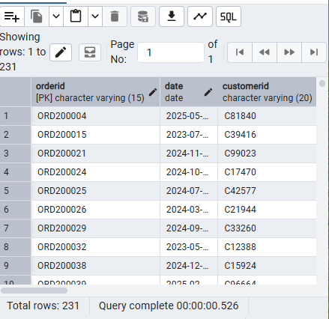

/*orders with Total Price greater than 5000*/
SELECT * FROM sales
WHERE TotalPrice > 5000;
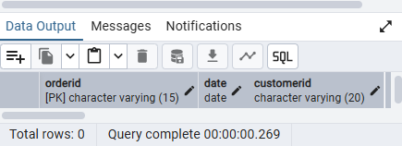

/*completed orders costing more than 3000*/
SELECT * FROM sales
WHERE OrderStatus = 'Delivered'
AND TotalPrice > 3000;
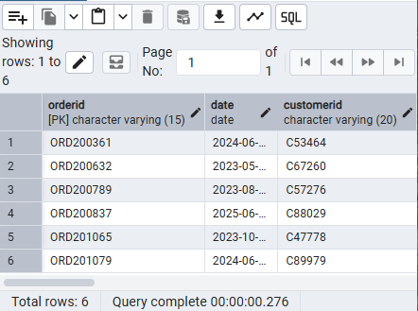

/*orders paid using Cash or Online Payment.*/
SELECT * FROM sales
WHERE PaymentMethod = 'Cash'
OR PaymentMethod = 'Online';
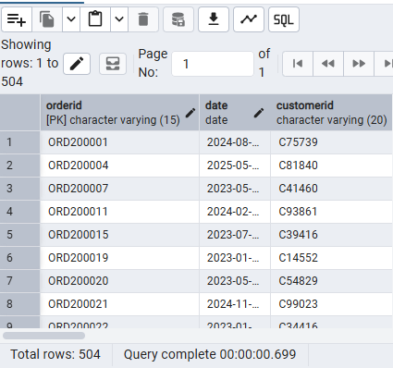

/*he most expensive orders first*/
SELECT OrderID, Product, TotalPrice FROM sales
ORDER BY TotalPrice DESC;
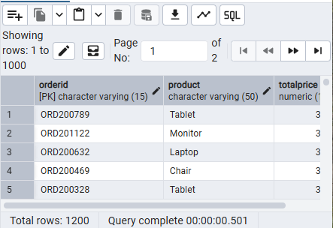

/*sort Lowest to Highest*/
SELECT OrderID, Product, TotalPrice FROM sales
ORDER BY TotalPrice ASC;
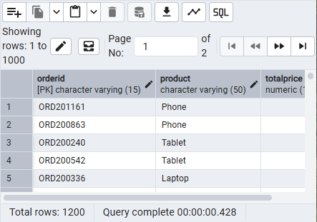

/*count Total Orders*/
SELECT COUNT(*) AS TotalOrders
FROM sales;
